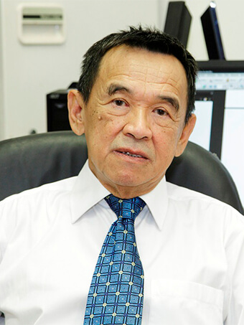
Current position: Professor, Head of department
Office: B1-204
Telephone: -
Email: ckong@xmu.edu.my

Biography
Prof Ong is the Head of Physics Department. He is also an adjunct professor in the National University of Singapore and a visiting Professor in Lanzhou University, China. He is a fellow of the Institute of Physics, UK. He served in an editorial board of Superconductor Science and Technology (2002-4), International Journal of Modern Physics B (2002-6), and Modern Physics Letter B (2002-6). He was a frequent visitor to the International Centre for Theoretical Physics, Trieste, Italy and Atomic Energy Research Establishment, Harwell, UK. He published more than 600 papers with H-index 50, one book on microwave published by Wiley and a US patent. He supervised 34 PhD students and 34 MSc students and 58 Honours year students while he was in the National University of Singapore. He was awarded an University Outstanding Researcher Award in the National University of Singapore in 2010.

Research Interest
- Microwave measurements and characterization
- Magnetic materials and magnetism
- Spintronics
- Quantum materials

Educational Background
- Bachelor Degree (Major), Department of Physics, Nanyang University, Singapore (1967)
- Master Degree (Major), Department of Physics, University of Manitoba,Canada (1971)
- Ph. D Degree (Major), Departmentof Physics, University of Manitoba, Canada (1973)

Working Experience
- Lecturer (1981-1982), Sr Lecturer (1982-1989), Assoc. Professor (1989-1993), Professor (1993-2017), Department of Physics, National University of Singapore.
- Senior Researcher Scientist, Temasek Laboratory, Singapore (2017)
- Adjunct Professor (2018-present), National University of Singapore
- Visiting Professor (2020-present), Lanzhou University, China
- Professor, Tohoku University, Institute of Electrical Communication, Sendai, Japan (June – November 2000)
- Concurrent Professor, Nanjing University, China (2000 – 2003)
- Research Associate, Atomic Energy Canada Ltd, Pinawa, Canada (1980 -1981)
- Lecturer (1976 -1977), Sr. Lecturer (1977 – 1980) Physics Department, Ahmadu Bello University, Nigeria

Representative Publications
- Invented a patent “Electrically Tunable Microwave Devices with Patterned Ferroelectric Thin Film”, received a US patent in 2005.
- Co-authored a book on “microwave electronics” published by Wiley (2004)
- Tay ZJ, Soh WT and Ong CK ‘Observation of electromagnetically induced transparency and absorptions in Yttrium Iron Garnet loaded split ring resonator.” Journal of magnetism and magnetic materials, 45, 235 (2018)
- Ma YG, Ong CK, Tyc T and Leonhardt U “An Omnidirectional retroreflector based on the transmutation of dielectric singularities.” Nature Materials 8 (8), 639 (2009)
- Wang DH, Goh WC, Ning M and Ong CK “Effect of Ba doping on magnetic, ferroelectric and magnetoelectric properties in multiferroic BiFeO3 at room temperature” Applied Physics Letters 88 (21) 212907 (2006)
- Liu Y, Chen LF, Tan CY, Liu HJ and Ong CK “Broadband complex permeability characterization of magnetic thin films using shorted microstrip transmission line pertubation” Review of Scientific Instruments, 76(6), 063911 (2005)
- Rao XS and Ong CK “Subwavelength imaging by a left-handed material superlens” Physical Review E 68, 0676501 (2003)
- Lim HS, Ong CK and Ercolessi F “Stability of face-centered cubic and icosahedral lead clusters” Surface Science, 269, 1 109(1992)

Honors / Awards
- Fellow and Chartered Physicist, Institute of Physics, UK (2000-present)
- Fellow, Singapore Institute of Physics, Singapore (1989-present)
- National University of Singapore Outstanding Researcher Award 2010
- President, Singapore Institute of Physics Singapore (1996 – 2000)
- Vice President, Singapore National Academy of Science (1998 – 2000)

